File Locations, Calibrating, Creating Trackables and Creating Joints

# File Locations

### Resources

Repository\Stromohab_08\Resources

Any new Calibrations, Trackables, Joint files or an updated NPTrackingTools.dll file should be placed in here, then “Update Files In Server Release Folder.cmd” should be run to push those new files out to the server.

### Server Project

Repository\Stromohab_08\Visual Studio Solutions\StroMoHab_TT_Server

Contains the server project, when it is built it automatically copy’s the needed files from the Resources folder to the Output Folder (The .exe looks for the needed files in the same folder it is executing from). However if any of the resources files are updated and the server isn’t going to be re-build/tested then “Resources\Update Files In Server Release Folder.cmd” should be run.

### Code

Repository\Stromohab_08\Code\Classes

Contains the base classes split into folders

* Client – Code related to the TCP Client
* Common – Code shared between the server and client applications (contains Marker, Camera, Trackables etc Definitions)
* FilteredMarkerProcessor – Code to filter out markers (Server Side)
* JointProcessor – Code to generate joints (Server Side)
* MotionCapture – Code to handle Motion Capture (Server Side)
* Plotting – Code to plot graphs (Client Side)
* Treadmill – Code to handle the Treadmill (Server Side)

# Calibrating

To calibrate the new server you must use Tracking Tools. Load up the program and select “Perform Camera Calibration”. Note this application can be very slow; this is because it maxes out the CPU on the server machine, resizing the window (more specifically the 2D Camera View Windows) to make it smaller generally helps. 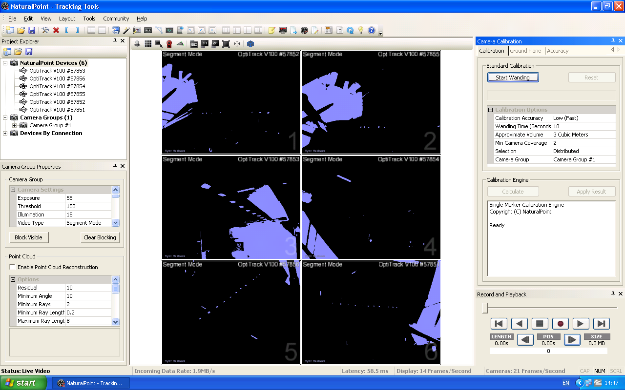

1. In the box Camera Group Properties on the left side, adjust the Exposure etc.
2. You can also right click on a camera and bring up its individual properties or change it to grey scale mode (this requires an exposure of around 100-200) to get a view of what the camera can see. Note either plug all the cameras in via the back or if using the hub only have one camera on grey scale mode at once.
3. In the box Camera Calibration on the right side

* Calibration Accuracy to High/Very High.
* Wanting Time to 120 or more

1. The press “Start Wanding”. When done the button “Calculate” becomes available, press it
2. Once done go to the “Ground Plane” tab, place the ground plane on the treadmill in a cantered position and press “Set Ground Plane”.
3. Then in Capture Volume Translation enter 53 in the Y box and press “Apply Translation” this accounts for the fact the markers on the ground plane aren’t at the level of the treadmill.
4. You can then go to File->Save Camera Calibration into the Resources folder and run “Resources\Update Files In Server Release Folder.cmd” or rebuild the server.

# Trackables

Trackables (used to be called Rigid Bodys) are defined using the Tracking Tools Software. Open it up and load in cali.cal and Trackables.tra from the Resources folder. Go to Layout-> Tracking and you will be presented with a screen that looks like this.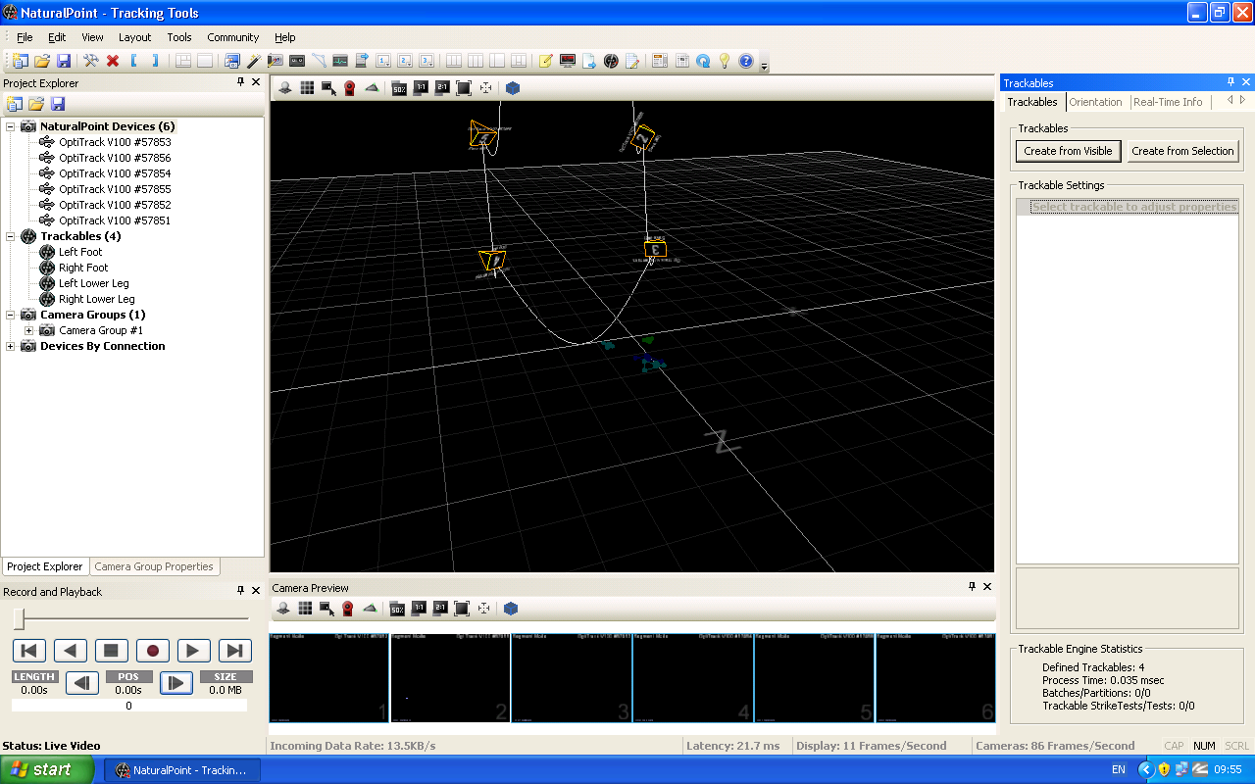

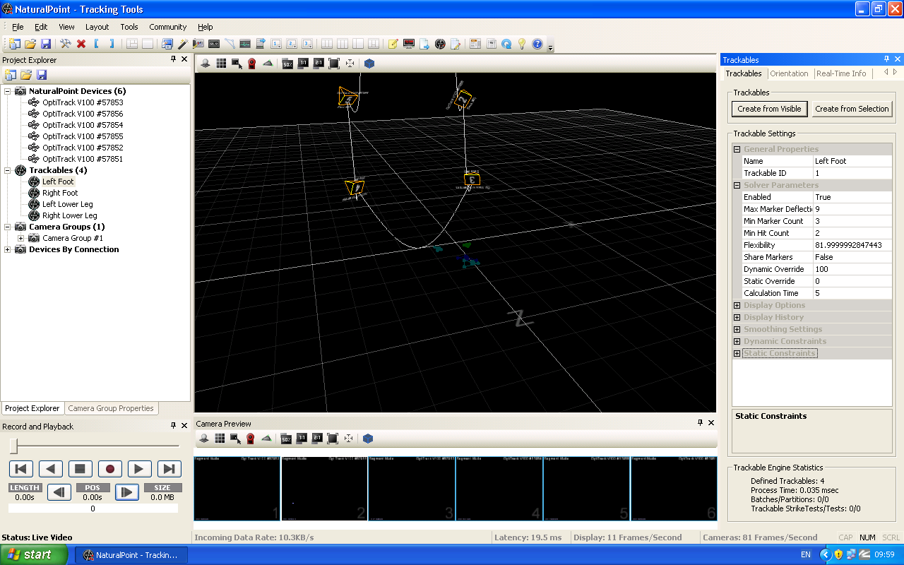On the left side you can see that there are already 4 Trackables Defined, and their last known location is shown faintly on the screen. Clicking on one of them (In the left hand panel) brings up their options (in the right hand panel) under the tab “Trackables”, moving the “Real-Time Info” will give you information about the Trackable.

To create a Trackable either put the Trackable (and only the Trackable) in front of the cameras and press “Create from Visible” or drag the mouse over the Trackable’s makers and press “Create from Selection”.

On the “Trackables” tab are the following key properties (Note clicking on them brings up a description) that must be set:

* Name – See Document Trackable and Joint ID Numbers
* Trackable ID - See Document Trackable and Joint ID Numbers

All the other fields will have an acceptable default value that doesn’t need to be adjusted.

However if the system is becoming to accurate and rejecting Trackables because of the markers moving by a small amount then the Max Marker Deflection and/or Flexibility should be increased. The overall effect is that markers can move further and change shape more while still tracking, however if two Trackables are two similar there is a greater chance that they will get mixed up or dropped.

Another property that will be useful is “Min Marker Count” – Example – A Trackable with 5 markers, setting this value to 3 will allow the Trackable to be tracked even when two marker aren’t visible.

Once done use File->Save Trackables to update the Resources Directory. Then run “Resources\Update Files In Server Release Folder.cmd” or test/re-build the server.

At the top of JointProcessor.cs (Code\Classes\JointProcessor\) there is the following line of code

private static int maxTrackableID = 20; // Specifies the Highest Trackable ID number

This will need to be increased if more Trackables are defined so that one of more has an ID number greater than or equal to maxTrackableID.

# Joints

The joints are stored as an xml file. It is explained in Joint.cs (Code\Classes\Common\Joint.cs). Here is an example file which defines the left and right Ankle. It is stored in Resources folder and is automatically copied to the server output directory when the server is re-built, or if needed run “Resources\Update Files In Server Release Folder.cmd”.

<?xml version="1.0" encoding="utf-8" ?>

<Joints> START OF THE FILE

<joint> START OF A JOINT

<id>1</id> UNIQUE JOINT ID

<name>Left Ankle</name> NAME OF THE JOINT

<trackable1>1</trackable1> THE TRACKABLE FURTHEST AWAY FROM THE BODY CENTER - FOOT

<trackable2>3</trackable2> THE TRACKALBE NEAREST THE BODY CENTER – LOWER LEG

<pitchOffset>0</pitchOffset> OPTIONAL OFFSET

<rollOffset>0</rollOffset> OPTIONAL OFFSET

<yawOffset>0</yawOffset> OPTIONAL OFFSET

</joint> END OF A JOINT

<joint>

<id>2</id>

<name>Right Ankle</name>

<trackable1>2</trackable1>

<trackable2>4</trackable2>

</joint>

</Joints> END OF THE FILE

To add extra information (not extra joints, but extra properties, e.g. maxPitch, maxRoll etc.) to the xml file edit the Load method of JointProcessor.cs (Code\Classes\JointProcessor\JointProcessor.cs) to allow the code to read it and edit Joints.cs to add the extra property.

Below is a section from JointProcessor.cs that would need to be copied to make a new entry, this can be re-written in terms of how it is constructed.

case "rollOffset":

newJoint.RollOffset = xmlJoints.ReadElementContentAsDouble();

break;

case "xml element name":

newJoint.Joint.cs Property Name = xmlJoints.ReadElementContentAs-TypeOfData();

break;